UNIT III AGILITY AND KNOWLEDGE MANAGEMENT
Agile Information Systems – Agile Decision Making – Earl_S Schools of KM – Institutional Knowledge Evolution Cycle – Development, Acquisition, Refinement, Distribution, Deployment, Leveraging – KM in Software Engineering – Managing Software Knowledge – Challenges of Migrating to Agile Methodologies – Agile Knowledge Sharing – Role of Story-Cards – Story-Card Maturity Model (SMM).s.

AGILE INFORMATION SYSTEMS
Agile Information Systems Development (ISD) principles emphasize self-organizing teams and empowered individuals in order to build more effective architecture and design. Agile ISD puts a higher emphasis of social interactions and human aspects of software development, and self-organizing teams act as enablers of these human aspects. In agile ISD teams, members have high autonomy over choosing their tasks and the way they perform the tasks. Team members benefit from the collective decision making and shared ownership of the project.

Agile ISD methods and practices have been widely adopted in the enterprise software industry. The principles of “The Agile Manifesto” emphasize self-organizing teams and empowered individuals in order to build enterprise systems more effectively. Self-organizing teams have been associated with high productivity satisfied employees, lower turnover, and lower absenteeism, and creativity. Self-organizing teams are fundamental features of agility in software development. Agile ISD teams are considered to be democratic, without a strict hierarchy. The process of decision-making resides now with the team members rather than with the team manager. Team members learn how to work together and how to mutually oversee each other. Agile ISD places a greater emphasis on people as well as on social interactions, which requires a higher degree of human empowerment and communications. An agile ISD team should be able to self-organize its challenges and constraints that have been posed by management. In general, a self-organizing team has autonomy over decisions about policies and programs, and is responsible for determining methods, procedures, and schedules and for making work-related decisions. The label “self-organizing teams” is most widely used as a synonym for “autonomous teams”. Some researchers use the terms “empowered teams” and “selforganizing teams” synonymously, while others differentiate between the concepts define team empowerment as having four dimensions: potency, meaningfulness, autonomy, and impact. In this study we use the term “self-organizing teams” the same as the term “autonomous teams”. However, the conceptual scope of “empowered teams” is more specific, since members of empowered teams also share a sense of doing

meaningful teamwork towards organizational objectives. Researchers try to study and understand self-organization and autonomy in agile ISD teams. However, a thorough analysis of team empowerment in agile ISD teams within four above mentioned dimensions is deemed to be useful. Team members may experience work overload, thus reducing their likelihood of exploring and learning. Therefore, the main objective of this paper is to develop an understanding of team empowerment in agile ISD teams.

What Is Agile Decision-Making in Project Management?

Information is available faster and from more sources than ever before, which makes decision-making seem easier.

Making decisions in an agile way means working iteratively, collaboratively, and with transparency. Pretty different from the older trend of having a task force craft a solution, the project manager present it, and executives come to a consensus, right? In agile project teams, managers, leaders, and executives need to release the reins and empower project teams to make decisions.

What is agile decision-making?
As stated above, agile decision-making is a process that is collaborative, iterative, and transparent. It means all stakeholders are updated on assigned tasks at regular intervals, they give feedback, and then the team knows what needs to be changed or improved. The team discusses issues together and comes up with a solution together.
Agile decision-making doesn’t mean rushed, on-the-fly changes at the whim of one project stakeholder. It also doesn’t mean that the project team makes all the decisions amongst themselves and then hands over a final product at the end.

Why you should adopt agile decision-making

Maintaining a course of action because that’s what has been successful for you in the past is no longer enough to be competitive. It can actually even lead to your downfall.
For example, Kodak infamously played it safe, underestimated the pace of change, and paid the price. Of course their bankruptcy was rooted in compounding issues, but their late adoption of digital transformation and lack of taking chances on new products were driving forces. They took the mindset that you don’t fix what isn’t broken and were left behind by competitors that were willing to try new things and new ways to operate.

But don’t equate agile project management with being as fast as possible and blowing up a budget with overtime to complete endless requirements. Working in an agile method means making iterative progress and changes as an empowered and self-organizing team.

Empower the project team to deliver what the customer wants (or senior leadership) in the manner they decide is the most efficient and successful. They won’t go down some rabbit hole, wasting hours or days, because an agile team checks in with the customer on a regular basis.

5 tips for agile decision-making

Iterative delivery and feedback is a key component in agile projects. Though this approach makes sense to businesses—adjust and make changes when needed, easy enough right?—it’s actually the most difficult

aspect of the agile method for people to get comfortable with. Here are a few tips to help you and your team be successful in agile decision-making during a project.

Tip #1: Gather iterative feedback

When you’re showing the work and getting feedback regularly, it reduces the chance of a major disruption that requires a complex decision-making technique with a formal committee. The team can make incremental pivots and adjustments as needed, without formal oversight or stress about deviating from a lengthy process document.

Tip #2: Balance alignment and autonomy

Your agile team needs to be empowered and well-informed when making decisions. But this doesn’t mean it can deviate from what the goals of the project are. Leaders often don’t give teams the autonomy needed because they fear the team going rogue and producing something completely off the wall.

An agile team will be showing their progress on a regular basis and getting feedback for changes. So for example, if a construction company tasks a team to build a new website, an agile team won’t decide one sprint that the website would be better if you could book travel arrangements on it instead and then proudly hand over a new “cheap flights” site to the construction manager.

Tip #3: Get comfortable with good enough

One huge mindset change that is needed is getting comfortable with “good enough.” The requirements are documented “good enough.” The timing to start is “good enough.”

Then, you can work toward “great” during the execution process. Yes, there will be work scrapped while sharpening what “great” looks like and that’s OK. When the whole team is accountable for the project’s success, it won’t be such an emotional hit if some of one person’s work has to be cut because of time. The team will support its members.

Tip #4: Place time limits on decisions

As project managers, we love timelines and due dates. And agile decision-making needs timelines. Set deadlines for when analysis must be cut off—is good enough. This helps alleviate analysis paralysis because you’re forced to move forward with a decision when it’s good enough rather than when it’s perfect.

Tip #5: Don’t get sloppy

Plan project meetings at a regular cadence to give updates, brainstorm for improvements, plan the next block of tasks for a sprint, and get iterative feedback on what’s been delivered. This cadence is what builds trust with senior leadership, improves the strength of the team, and builds the team’s confidence in their decision-making skills.
Earl's7KnowledgeManagementSchools

Knowledge, being such slippery and elusive term to define, has led to so many theories and assumptions to prop up with no converge - more confusion and chaos. Knowledge Management Systems (KMS) - some commentators call them Expert Systems (ES) - have been developed to aid the knowledge management efforts. These KMSs try to simulate the intellect of the human expertise in creating, storing, sharing and

transferring knowledge. Simply said, KMS is
a
process, not knowledge itself.
However, the management of this knowledge needs some sort of classification to give some semblance of order. In 2001, Michael Earl tried to map knowledge management into a taxonomy of seven KMS schools, each based on existing and observable practice. This taxonomy grouped these schools into three categories,
namely:

- Technocratic
- Economic
- Behavioural

In their supplemental paper to Earl's framework, Deborah Blackman and Steven Henderson (Blackman and Henderson, 2005) have helped summarise the seven schools as follows:
- Systems school. This school puts emphasis on knowledge creation with no help available, that is further validated by esteemed peers, codified and stored in a KMS. To me, this is "learning the hard way". A question arises: What criteria is used to label one an esteemed peer, or who holds these esteemed peers in such high esteem?
- Cartographic school. In this school, KMS identifies only the knower of the tacit knowledge i.e. it is a directory of experts
- Process school. This school consists of two components arising from business process reengineering (BPR) i.e. the description of the process plus output generated by such process. It seems to be a hybrid between systems and cartographic schools.

Earl classified these three schools i.e. process, cartographic and systems in the "technocratic" category. They lack knowledge on business performance improvements, even though this missing knowledge is available within the organization and can be transferred effectively and accurately.
- Commercial school. As the name suggests, this school seeks to market and sell knowledge as a commodity. Unlike the technocratic schools where knowledge is accessed and shared to knowledge seekers, this school restricts knowledge to customers an organization considers profitable. It is the only one Earl categorized as "economic".
- Organizational school. This school focuses on collaborating knowledge in a learning community by strengthening the ties between different knowledge holders. It is a community of practice (CoP).
- Spatial school. This school fronts its argument that modern management practices - such as hierarchical structures -, commercial buildings and technology are an antithesis to a conducive environment for learning, knowledge sharing, discussions and bonding. It suggests that space must be set aside for exciting new ideas to emerge. Thus the name spatial.
- Strategic school. The name says it all. A word of caution though: it doesn't mean that all the other schools cannot support an organization's competitive strategy. The difference of thought with this school compared to others is that in the other schools, not all knowledge is immediately strategic. Also, this school looks at, in addition to the internal improvements and problem solving, the bigger corporate picture.

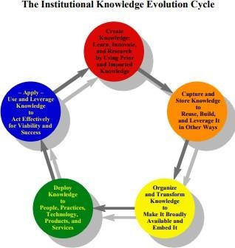
Institutional Knowledge Evolution Cycle

Models of Knowledge Management Cycle
Knowledge management cycle is a process of transforming information into knowledge within an organization. It explains how knowledge is captured, processed, and distributed in an organization. In this chapter, we will discuss the prominent models of knowledge management cycle.
Till date, four models have been selected based on their ability to meet the growing demands. The four models are the Zack, from Meyer and Zack (1996), the Bukowitz and Williams (2000), the McElroy (2003), and the Wiig (1993) KM cycles.

Zack | Bukowitz & Williams | WIIG | McElroy
Acquisition | Get | Creation | Learning
Refinement | Use | Sourcing | Validation
Store | Learn | Compilation | Acquisition
Distribution | Contribute | Transformation | Integration
Presentation | Assess | Application | Completion

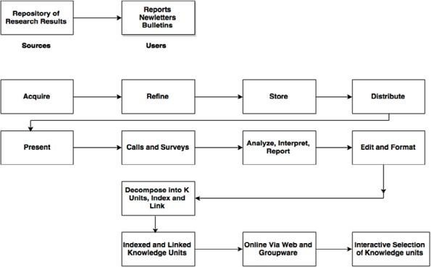
Zack Knowledge Management Model
The Zack model is extracted from work on the design and development of information products. In Meyer and Zack’s approach, the network between each stage is designed to be logical and standardized.
In this cycle, the major developmental stages of a knowledge repository are analyzed and mapped to the stages of a KM cycle.
The stages are acquisition, refinement, storage/retrieval, distribution, and presentation/use. This cycle is also known as the “refinery.”

Acquisition of Data or Information
Acquisition deals with issues regarding origin of raw materials such as scope, breadth, depth, credibility, accuracy, timeliness, relevance, cost, control, and exclusivity.
The guiding principle is the well- known proverb of “garbage in, garbage out.” That is, highest quality source data is required, else the intellectual products produced downstream will be lower.

Refinement
Refinement may be physical (like migrating from one medium to another) or logical (like restructuring, relabeling, indexing, and integrating.)
Refining also defines cleaning up (like sanitizing content so as to ensure complete anonymity of sources and key players involved) or standardizing (like conforming to templates of a best practice or lessons learned as used within that particular organization).
This stage also adds up to the value by creating more readily usable knowledge objects and by storing the content more flexibly for future use.

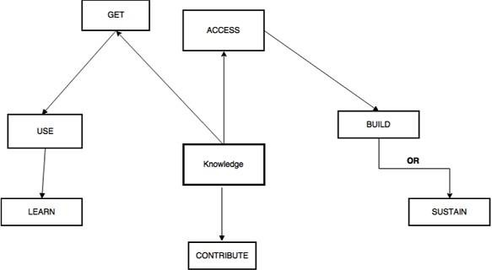
Storage / Retrieval
Storage or Retrieval forms a bridge between the upstream addition and refinement stages that feed the repository and downstream stages of product generation. Storage can be physical (file folders, printed information) as well as digital (database, knowledge management software).

Distribution
Distribution defines how the product is to be delivered to the end-user (like fax, print, email) and encloses not only the medium of delivery but also its timing, frequency, form, language, and so on.

Presentation
Context plays an important role in Presentation or Application stage. The performance of each of the preceding value-added steps is evaluated here – for example, does the user have enough context to be able to make use of this content? If not, the KM cycle has failed to deliver value to the individual and ultimately to the company.
The repository and the “refinery” combined enable the management of valuable knowledge of a firm. In this cycle, there is also an impression of having to continually renew the repository and the refinery in order to avoid elimination.
The Meyer and Zack model is one of the most complete picture of the key elements engaged in the knowledge management model. To be specific the notion of refinement is a crucial stage in the KM cycle and one that is often neglected.

Bukowitz & Williams Model
Bukowitz and Williams portray a knowledge management process framework that outlines “how organizations generate, maintain and expand a strategically correct stock of knowledge to create value”.
In this framework, knowledge includes knowledge repositories, relationships, information technologies, communications infrastructure, functional skill sets, process know-how, environmental responsiveness, organizational intelligence, and external sources.

These stages aim on more long-range processes of matching intellectual capital to strategic needs.

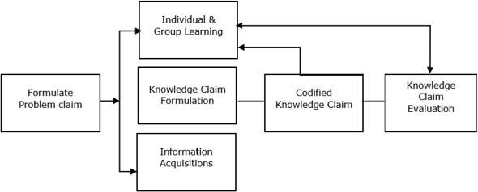
- Get Stage is the first stage, it consists of seeking out information required in order to make decisions, solve problems, or innovate.
- Use Stage is the next stage, and it deals with how to combine information in new and interesting ways in order to foster organizational innovation. The spotlight is primarily on individuals and then on groups.
- The Learn Stage points to the formal process of learning from experiences as a means of creating competitive gain. Learning in enterprises is important because it serves the transition step between the application of ideas and the generation of new ones.
- The Contribute Stage of the Knowledge Management cycle deals with encouraging employees to post what they have learnt to the communal knowledge base (like a repository). Only in this way, can individual knowledge be made visible and available to the entire organization, where and when appropriate.

McElroy Model
McElroy outlines a knowledge life cycle that consists of the processes of knowledge production and knowledge integration, with a series of feedback loops to organizational memory, beliefs, and claims and the business-processing environment.
- Problem claim formulation is an attempt to learn and state the specific nature of the detected knowledge gap.
- Knowledge claim formulation acts as a response to approved problem claims via information acquisition and individual and group learning.
- New knowledge claims are tested and examined through knowledge claim evaluation processes.
- Evaluation of knowledge claims results in surviving knowledge claims that will be integrated as new organizational knowledge or falsified/undecided knowledge claims.
Experience gained from the application of knowledge in the organizational knowledge base leads to new claims and resulting beliefs, triggering the cycle to begin all over again.
In knowledge production, the primary processes are individual and group learning. Knowledge claim formulation, information acquisition; codified knowledge claim and knowledge claim evaluation.

These knowledge production processes can be briefed as −
- Individual and group learning marks the first step in organizational learning.

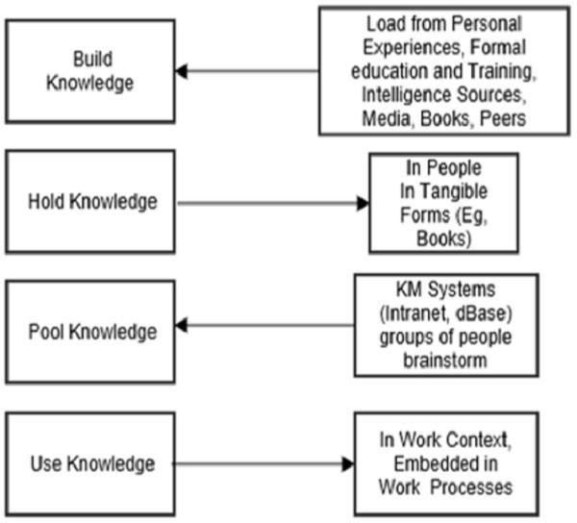
- Knowledge claim validation includes codification at an organizational level.
- A formalized procedure is essential for the receipt and codification of individual and group innovations.
- Information addition is the process by which an organization deliberately or serendipitously acquires knowledge claims or information produced by others, usually external to the company. This stage plays a basic role in formulating new knowledge claims at the organizational level.
Knowledge integration is the process by which an organization announces new knowledge claims to its operating environment and retires old ones. It includes all knowledge transmission such as teaching, knowledge sharing, and other social activities that either connects an understanding of previously produced organizational knowledge to knowledge workers or accommodate newly minted knowledge.
One of the advantages of the McElroy cycle is the clear description of how knowledge is examined and a conscious decision is made as to whether or not it will be included into the organizational memory. The authorization of knowledge is a step that clearly differentiates knowledge management from document management. The KM cycle aims at processes to identify knowledge content that is of value to the organization and its employees

WIIG Model
WIIG highlights the three conditions that need to be present for an organization to conduct its business successfully.
- It must have a business (commodities/services) and customers.
- It must have resources (people, budget, and facilities).
- It must have the strength to act.
WIIG marks the major purpose of KM as an effort “to make the organization intelligent-acting by facilitating the creation, accumulation, deployment and use of quality knowledge.” WIIG’s KM cycle shows how knowledge is built and used as individuals or as organizations.
The following figure shows the four major steps of the WIIG model.

- Building knowledge − From external and internal knowledge sources
- Holding knowledge − Storing the information in a particular form

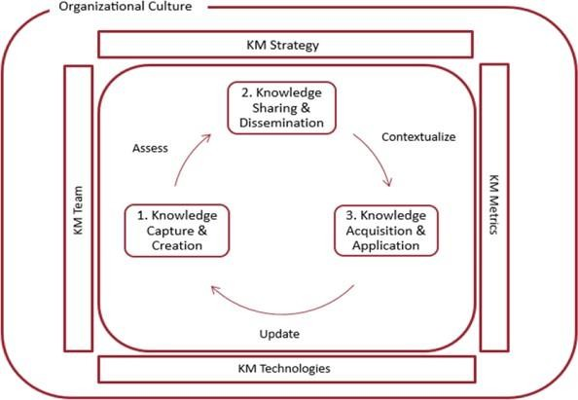
- Pooling knowledge − Through intranets and knowledge management portals
- Applying knowledge − In the context of work embedded in process

Integrated Cycle
The following are the three major stages of integrated cycles of knowledge management strategy when introduced in any organization −

- Knowledge capture and/or creation
- Knowledge sharing and dissemination
- Knowledge acquisition and application

Knowledge Capture states the identification and frequent codification of existing (usually previously unnoticed) internal knowledge and know-how within the organization and/or external knowledge from the environment.
Knowledge Creation is the advancement of new knowledge and know-how innovations that did not have a previous existence within the organization.
Once, it is clear that the newly identified content is of sufficient value, the next step is to contextualize this content. This involves maintaining a connection between the knowledge and those knowledgeable about that content.
Contextualization also indicates identifying the key elements of the content in order to better match to a variety of users. Finally, contextualization succeeds to when the new content is firmly, precisely yet seamlessly, embedded in the business processes of the enterprise.
The knowledge management cycle is then rechecked as users understand and decide to make use of content.
The users will update usefulness, and they will signal when it becomes out of date or when this knowledge is not applicable.

KNOWLEDGE MANAGEMENT IN SOFTWARE ENGINEERING
Knowledge management is an expanding and promising discipline that has drawn considerable attention. Recent developments in computer and IT technologies enable sharing documented knowledge independently of time and location

Requirement of Knowledge Management in the Software Industry
Software organizations’ main assets are not plants, buildings, or expensive machines. A software organization’s main asset is its intellectual capital, as it is in sectors such as consulting, law, investment banking, and advertising. The major problem with intellectual capital is that it has legs and walks home every day. At the same rate, experience walks out the door, inexperience walks in the door. Whether or not many software organizations admit it, they face the challenge of sustaining the level of competence needed to win contracts and fulfill undertakings. Knowledge management is an emerging discipline that promises to capitalize on organizations’ intellectual capital. The concept of taming knowledge and putting it to work is not new; phrases containing the word knowledge, such as knowledge bases and knowledge engineering, existed before Knowledge Management became popularized.
The KM concept emerged in the mid-1980s from the need to derive knowledge from the "deluge of information" and was mainly used as a "business world" term. In the 1990s, many industries adopted the term KM in connection with commercial computer technologies, facilitated by development in areas such as the Internet, group support systems, search engines, portals, data and knowledge warehouses, and the application of statistical analysis and AI techniques. KM implementation and use have rapidly increased since the 1990s: 80 percent of the largest global corporations now have KM projects. Over 40% of Fortune 1000 companies now have a chief knowledge officer, a senior-level executive who creates an infrastructure and cultural environment for knowledge sharing.

Need of Knowledge Management in Software Engineering
Software development is a quickly changing, knowledge-intensive business involving many people working in different phases and activities. The available resources are not increasing along with the increasing needs; therefore, software organizations expect a rise in productivity. Knowledge in software engineering is diverse and its proportions immense and steadily growing. Organizations have problems identifying the content, location, and use of the knowledge. Improved use of this knowledge is the basic motivation and driver for KM in software engineering and deserves deeper analysis.

Benefits of Knowledge Management to Business Organizations

Decreasing time and cost and increasing quality
Organizations constantly need to decrease software projects’ development time and costs. Avoiding mistakes reduces rework; repeating successful processes increases productivity and the likelihood of further success. So, organizations need to apply process knowledge gained in previous projects to future projects. Unfortunately, the reality is that development teams do not benefit from existing experience and they repeat mistakes even though some individuals in the organization know how to avoid them. Project team members acquire valuable individual experience with each project - the organization and individuals could gain much more if they could share this knowledge.

Making better decisions
In software development, every person involved constantly makes technical or managerial decisions. Most of the time, team members make decisions based on personal knowledge and experience or knowledge gained using informal contacts. This is feasible in small organizations, but as organizations grow and handle a larger volume of information, this process becomes inefficient. Large organizations cannot rely on informal sharing of employees’ personal knowledge. Individual knowledge must be shared and leveraged at project and organization levels. Organizations need to define processes for sharing knowledge so that employees throughout the organization can make correct decisions.

Benefits of Knowledge Management to Software Organizations
Software organizations have vast amounts of knowledge in various areas, such as knowledge that is critical to achieving business goals. Let us look at some of these knowledge areas and organizations’ related needs. Acquiring knowledge about new technologies
The emergence of new technologies makes software development more efficient, but at the same time, they can be a project manager’s worst nightmare. It is difficult for developers to become proficient with new technology and managers to understand its impact and estimate a project’s cost when using it. When developers or project managers use technology that a project’s team members are unfamiliar with, engineers often resort to the "learning by doing" approach, which can result in serious delays. So, organizations must quickly acquire knowledge about new technologies and master them.

Accessing domain knowledge
Software development requires access to knowledge not only about its domain and new technologies but also about the domain for which software is being developed. An organization must acquire new domain knowledge either by training or by hiring knowledgeable employees and spreading it throughout the team. Sharing knowledge about local policies and practices
Every organization has its own policies, practices, and culture, which are not only technical but also managerial and administrative. New developers in an organization need knowledge about the existing software base and local programming conventions. Unfortunately, such knowledge typically exists as organizational folklore. Experienced developers often disseminate it to inexperienced developers through ad hoc informal meetings; consequently, not everyone has access to the knowledge they need. Passing knowledge informally is an important aspect of a knowledge-sharing culture that should be encouraged. Nonetheless, formal knowledge capturing and sharing ensures that all employees can access it. So, organizations must formalize knowledge sharing while continuing informal knowledge sharing.

Capturing knowledge and knowing who knows what
Software organizations depend heavily on knowledgeable employees because they are key to the project’s success. However, accessing these people can be difficult. Software developers apply just as much effort and attention to determining whom to contact in an organization as they do getting the job done. These knowledgeable people are also very mobile. When a person with critical knowledge suddenly leaves an organization, it creates severe knowledge gaps - but probably no one in the organization is even aware of what knowledge they lost. Knowing what employees know is necessary for organizations to create a strategy for preventing valuable knowledge from disappearing. Knowing who has what knowledge is also a requirement for efficiently staffing projects, identifying training needs, and matching employees with training offers.

Collaborating and sharing knowledge
Software development is a group activity. Group members are often geographically scattered and work in different time zones. Nonetheless, they must communicate, collaborate, and coordinate. Communication in software engineering is often related to knowledge transfer. Collaboration is related to the mutual sharing of knowledge. Group members can coordinate independently of time and space if they can easily access their work artifacts. So, group members need a way to collaborate and share knowledge independently of time and space.

CHALLENGES OF MIGRATING TO AGILE METHODOLOGIES
While object-oriented (OO) approaches provide a viable method to incrementally develop information systems, a host of new methods called agile development methodologies or lightweight methodologies claim to go a step further in overcoming the limitations of traditional plan-driven ones. A number of software development methods such as extreme programming (XP), feature-driven development, crystal clear method, scrum, dynamic systems development, and adaptive software development, fall into this category. The advent of these methodologies has divided the software development community into opposing camps of traditionalists and agilists, with each group proclaiming the superiority of its own methodology. A more

balanced view of the two competing methodologies is offered by a few who suggest that each method has its strengths as well as limitations, and is appropriate for specific types of projects. According to Boehm, “organizations must carefully evolve toward the best balance of agile and plan-driven methods that fits their situation.” Clearly, most organizations cannot ignore the agile wave, but for organizations steeped in the traditional systems development methodologies, adoption of agile methodologies will likely pose several challenges, since the two software development methodologies are grounded in opposing concepts. Past research shows that software development process changes represent complex organizational change phenomena and cannot be accomplished merely by replacing current tools and technologies with new ones. Such changes may impact several aspects of the organization including its structure, culture, and management practices. Therefore, understanding organization wide ramifications of a change phenomenon is a critical first step in planning and managing such changes. In this article, we have consciously taken an organizational and managerial perspective of this change phenomenon primarily because such a perspective, although critical in implementing organizational change, is largely missing from the current discourse on adoption of agile methodologies. We provide a brief comparison of agile development methodologies with traditional systems development methodologies, and discuss the challenges of adopting agile methodologies. Software development is a complex activity characterized by tasks and requirements that exhibit a high degree of variability.

Uncertainties are further compounded by the diversity and unpredictability of people who engage in such tasks. The changing nature and sophistication of tools (for example, a development environment including programming languages, techniques, and so on) may also exacerbate development problems. A rationalized, engineering-based approach has dominated software development almost since its inception. Such an approach, grounded in the principles of hard systems thinking, assumes that problems are fully specifiable, and that an optimal and predictable solution exists for every problem. Extensive upfront planning is the basis for predicting, measuring, and controlling problems and variations during the development life cycle. The traditional software development approach is process-centric, guided by the belief that sources of variations are identifiable and may be eliminated by continually measuring and refining processes. The primary focus is on realizing highly optimized and repeatable processes. Thus, planning and control accomplished by a command and control style of management provide the impetus for developing a software product. Systems development in the traditional approach is guided by a life cycle model such as the waterfall model, the spiral model, or some variations of these.
The life cycle model specifies the tasks to be performed and the desired outcomes of each phase, and assigns roles (such as systems analyst, programmer) to individuals who will perform these tasks. In addition to the end product of working code, these methodologies also produce a large amount of documentation that codifies process and product knowledge. Communication among project participants is formalized through these documents. Customers play an important role during specification development, but their participation is minimal in other activities. These methodologies are appropriate both for OO and nonOO technologies. Unlike the traditional methodologies, agile methodologies deal with unpredictability by relying on people and their creativity rather than on processes. They are characterized by short iterative cycles of development driven by product features, periods of reflection and introspection, collaborative decision making, incorporation of rapid feedback and change, and continuous integration of code changes into the system under development. A project is broken down into sub-projects, each of which typically involves planning, development, integration, testing, and delivery. Developers work in small teams with customers (representing system users) as active team members. The features to be implemented in each development cycle are jointly decided by the customer and the rest of the development team.
Collaborative decision making involving stakeholders with diverse backgrounds and goals is thus a characteristic of agile development. Agile methodologies favor a leadership-and-collaboration style of management where the project manager’s role is that of a facilitator or coordinator. The deliverable of each development cycle is working code that can be used by the customer. Agile methods discourage documentation beyond the code. Product knowledge, therefore, becomes tacit. Rotation of team membership

ensures this knowledge is not monopolized by a few individuals. Further, the iterative strategies that characterize agile methodologies are best supported by OO technologies. The evolutionary-delivery model proposed by Gilb provides a meaningful framework to guide agile software development [9]. To summarize, agile development is characterized by social inquiry in which extensive collaboration and communication provide the basis for collective action [5, 6, 8]. Diverse stakeholders including developers and end users go through repeated cycles of thought-action-reflection that foster an environment of learning and adaptation. Team members, empowered with more discretionary and decision-making powers, are not confined to a specialized role. This increases the diversity/variety of the teams and enables them to self-organize and respond with alacrity to emergent situations.

Story card
A story card is one unit of delivery for an agile team. We recommend each has five basic elements, which intentionally give enough detail for the team, but also leaves room for a conversation to later fill out the details (more on that in INVEST rule).

The five basic elements to include:
- Title or phrase. Quickly signifies the task for the team to see on the storyboard, kanban board, scrum board, or other progress visualization tool.
- Value statement. This is a condensed user story, showcasing the stakeholder and what the benefit of the feature is.
- Basic requirements for the story. In a sentence or two, provide initial expectations for what this feature should be.
- Size or estimation. Sizing helps teams make predictions on when work will be completed and is vital for scrum teams to plan. On your story card, this may be a number (e.g. 3, 5, 8, etc.) or a size (e.g. small, medium, large).
- Acceptance criteria. This is the basic benchmark that must be met to consider this card complete.

